**Relationship between Wash indicators and Food security**

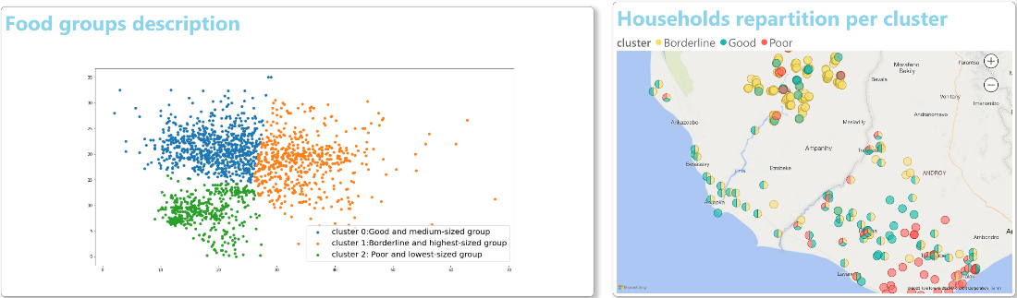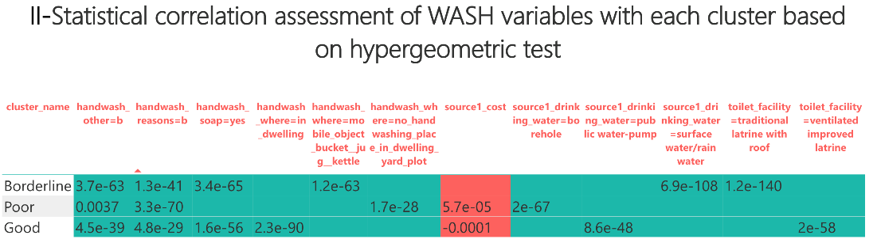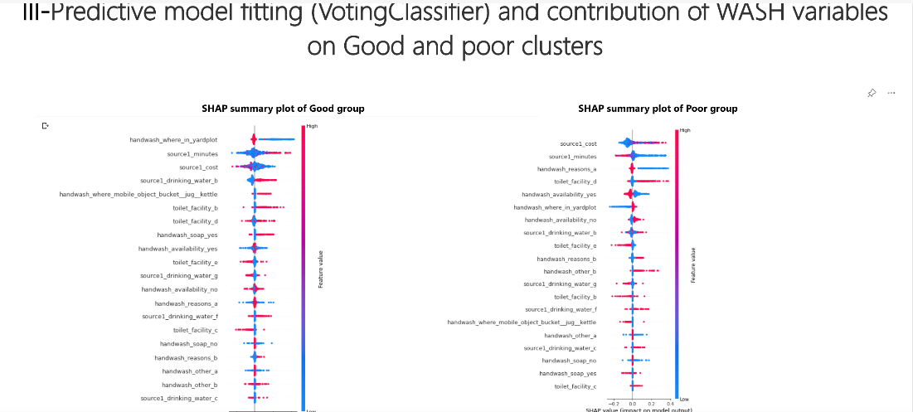

**Context and Problem:** Understanding food security and vulnerability has always been challenging. Yet the emergence of relatively new phenomena such as the recent high food and fuel prices, the global financial crisis, and climate change, all highlight the need to better understand the lives and livelihoods of vulnerable populations so that effective policies and actions can be implemented to save lives and address the root causes of hunger. A food insecurity situation analysis combines in general international standards - including food consumption levels, livelihoods changes, nutritional status, and mortality - and triangulates them with several contributing factors (food availability, access, utilization and stability, and vulnerability and hazards) analyzed within local contexts. This such anlysis, only related to food variables, suffers then from ability to identify and measure all the potential cofounders which have no direct link with food. This study tries ti analyze how WASH variables can impact Food security

**Database:** The data (WASH and Food) used come from MIRA-MAHARO

**Repository: the documented notebook**

[**https://colab.research.google.com/drive/1y_2dgn-a_BZC_MFlSJTzf4V4gQN2T_8P**](https://colab.research.google.com/drive/1y_2dgn-a_BZC_MFlSJTzf4V4gQN2T_8P)

**Process**:

1. We link WASH and Food data using Household ids

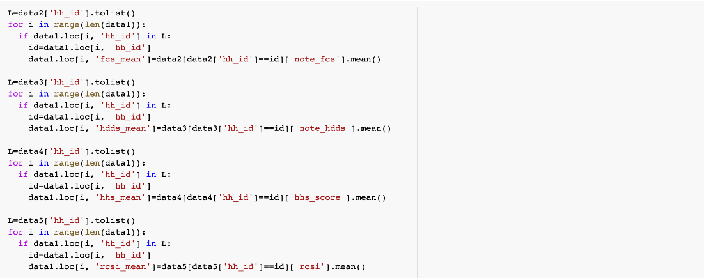

1. Using Food variables, we do clustering to identify Food groups in the data

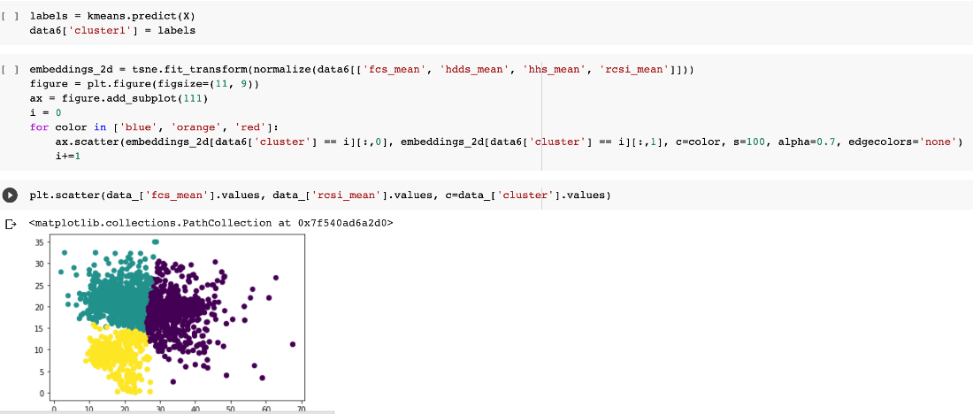

1. We use some statistics tests (hypergeometric) to assess correlation of WASH variables with clusters or Food groups

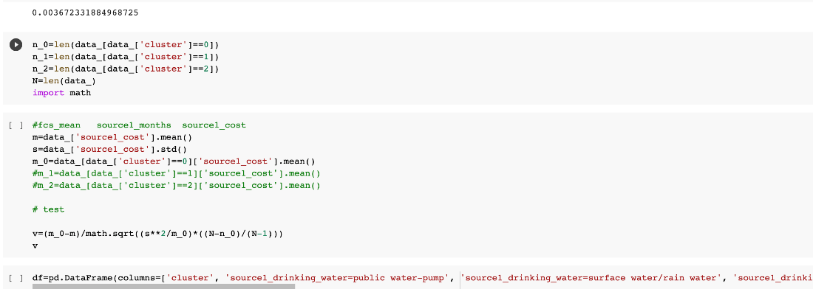

1. We build predictive model on WASH variables (used as features) and clusters variable (used as target), after checking independence, lack of interaction of WASH variable

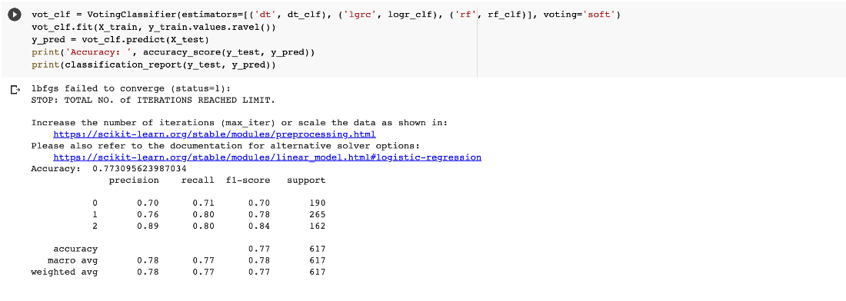

1. We use SHAP interpretable analysis to understand contributions of WASH variables on the predictions and deduce relationship between WASH variables and Food security

